International Debt Analysis

Chiranjeevi Mallavarpu, Ramya Mandava, Sabitri KC, Kim Wong

Southern Methodist University

Dallas

**Abstract:** The World Bank International Debt dataset provides the detailed picture of debt stocks and flow data on the external debt of individual low and middle income countries. It also showcases other debt data collected and compiled by the world bank so we were able to analyze the statisctics of highest and lowest debt country, the category of highest debt across different countries and check their patterns. We were also able to explore if the income level has any effect on the overall debt of the country. The data was accessed via world Bank data portal <https://data.worldbank.org/data-catalog/international-debt-statistics> and MySQL on IBM bluemix is used to extract the insights of this dataset.(summary of the work)

**1.Introduction**

The International Debt statistics contains more than 200 debt and financial flows indicators for over 130 countries that report public and publicly-guaranteed debt to the World Bank reporting system. The database runs from 1970 to 2016 and pipeline data for scheduled debt service payments on existing commitments to 2024. The database covers external debt stocks and flows, major economic aggregates and key debt ratios as well as average terms of new commitments, currency composition of long term debt, debt restructuring and schedules debt service projections. The dataset includes 5 tables. Total size of data is 155 MB. The database server is MYSQL (5.7.19) on IBM Bluemix and total memory size is,1GB.

(background of your work, why your work or this topic is important)

2. Background

International debt known as total external debt is categorized into (as per ref. 3) short-term debt, long-term debt and use of IMF credits (figure 1).

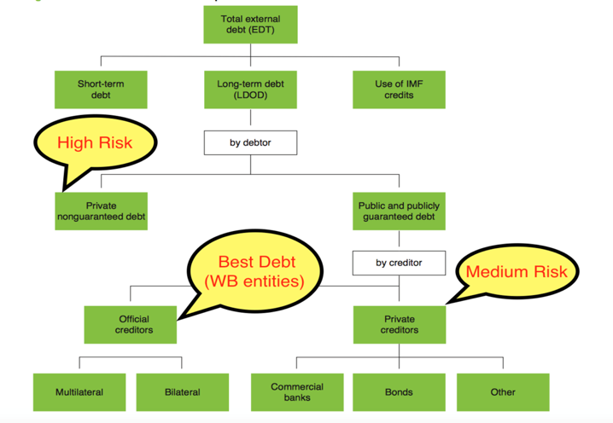

Figure 1. International Debt Categories

In the initial data exploration (as per figure 2, ref 5.) over period of time, we determined that 2016 seems to be latest data available across all countries. So, our approach would be to include only 2016 data to answer our questions of interest.

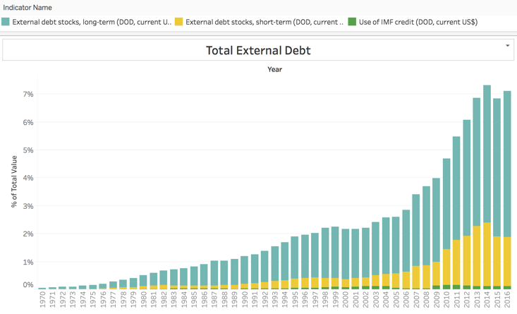

Figure 2. Yearly total external debt

We further realized that the long-term debt is the majority component (73%) of the total external debt (figure 3) hence we further focused on analyzing this component of debt across different countries when we wanted to analyze debt categories.

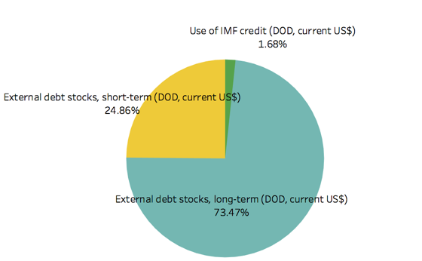

Figure 3. High Level Debt Categories 2016

Part of our analysis is also find out the overall economic status of different countries with respect to what sort of debt they are majorly into. In order to do such an inquiry we sort the debt categories in the following order of their preference.

‘Official Creditors’ – Considered to be best debt as it includes world bank and its entities with lowest interest rates. Next best is ‘Private Creditors’ – as it includes some sort of guaranteee from banks etc. The least preferred is the ‘Private Nonguaranteed’.

**3. Analysis**

Our key questions of interest are as below:

**Which country has the highest total debt?**

For the dataset in scope, **China** seems to have the highest external debt [1] i.e. **$1430 Billion** across all [2] countries (refer to figure 4 for few top countries).

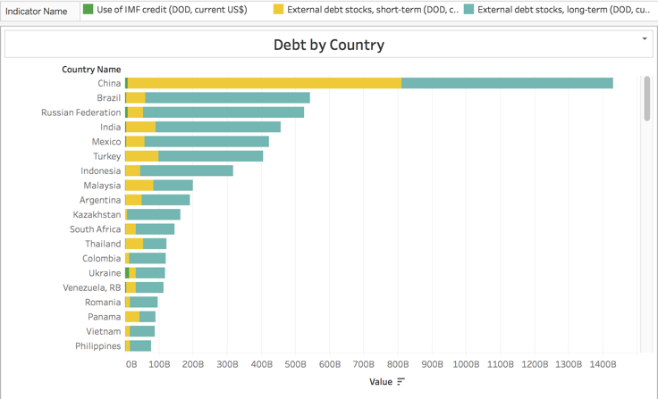

Figure 4. Debt by Country

**Which country has the least total debt?**

**Tonga** (a Polynesian island) seems to have the lowest external debt [1] i.e**. $0.16** **Billion** across all [2] countries

**What category of debt within long-term debt is highest across different countries?**

Within long-term debt, private non-guaranteed category contributes majorly towards the international debt (**49.4%**). Official creditors (World Bank entities) contributing least (**20%) –** figure 5.

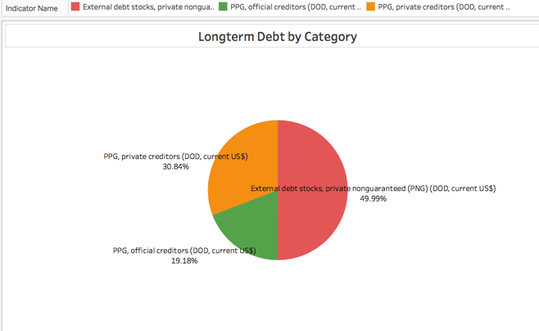

Figure 5. Long-term debt by Category

**Additional insights**: Although **China** tops the list in overall debt, when it comes to good debt as described in section 2, **India** seems to have highest debt of ‘Official Creditors’ and **Mexico** seems to have highest debt under ‘Private Creditors’(figure 6).

[1] External debt comprises of long-term debt, short-term debt, use of IMF credit

[2] The countries in scope for this exercise are only those countries that are developing countries

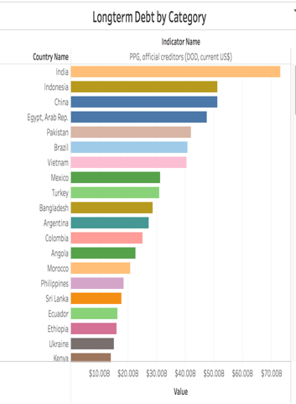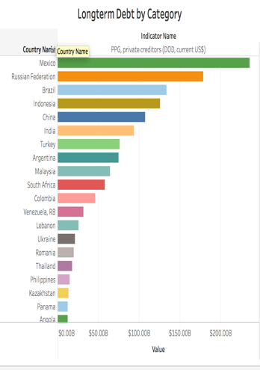

Figure 6. Official Creditors, Private Creditors

**Does the income level has any effect on the long term debt level of the country?**

The average debt of countries with Upper middle-income level seems to be Highest (64%) among all the countries and Low-income level seems to be the least.

We went ahead and did a linear regression on the long-term debt data vs GDP of each country (ref. 4). As depicted in figure 7, 8 the data complies to a linear regression model with a R-squared value of 0.8612(great value) indicating a HIGH correlation of debt of the country and its GDP value. The positive slope of the trend line indicates it is a positive relationship – the higher the GDP the higher the debt.

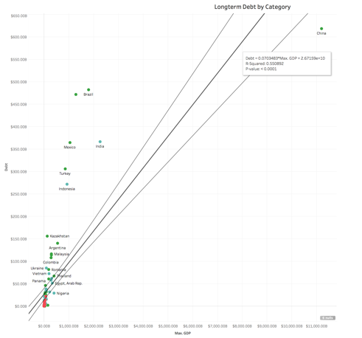

Figure 7. Linear Regression (including China)

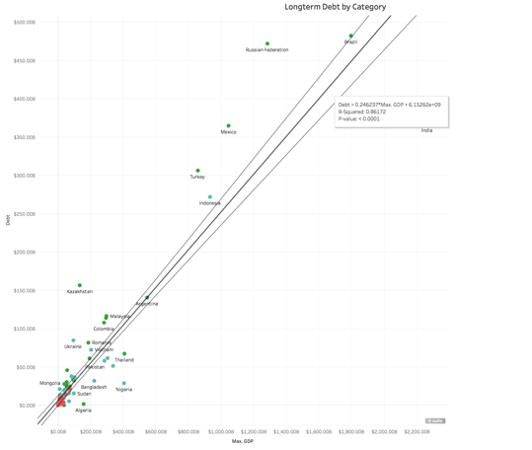

Figure 8. Linear Regression (excluding China)

Further we found visual evidence (figure 9) that all the countries that fall under low income level are actually below the trend line supporting the inference above and lower middle income on both sides of trend line and upper middle income above the trend line.

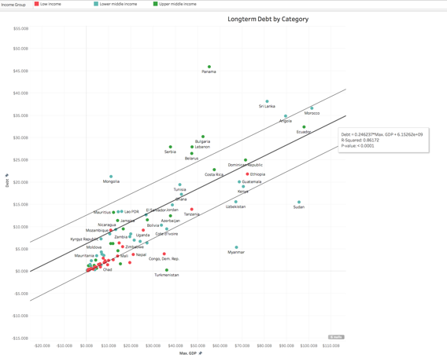

Figure 9. Income Level Vs Trend Line

**3.1 SQL code link at GitHub:**

<https://github.com/skc00/DBMS-Term-Project/blob/master/SQLScript_Output.docx>

**3.2 GitHub link for tutorial:**

<https://github.com/skc00/DBMS-Term-Project>

**4. Related / Existing Work**

The International Debt dataset is a public dataset from world bank available at <https://cloud.google.com/bigquery/public-data/world-bank-international-debt>. While the Google analysis is about present value of External Debt(lifetime), we focused on debt outstanding as of year 2016. This is to ensure we have comparable analysis (on the same terms) and minimize the need to make assumptions on what is the relevant rate to discount specific currency, given country-specific circumstances and changes that may happen over the life of the debt. In addition, 2016 had the most complete data to date for most countries. We also ventured into a new perspective, analyzing metrics such as debts via official creditors vs private non-guaranteed, income level of the country and distribution of most owned debt categories. This will expand our understanding of what kind of debt instrument were widely used and what income level have access to such instruments. (Present the existing work and how it is different from your work.)

**5. Conclusion**

The International Debt dataset from world bank website was analyzed and found some important insights. On an average **long-term** external debt seems to be highest across all countries. **China** seems to have **highest** external debt and **Tonga** (a Polynesian island) seems to have **lowest** external debt across all countries. On an average **long-term external debt** seems to be **highest** across all countries. Within the long-term debt, **Private nonguaranteed** category contains **49%,** which is a bit surprising indicating most of the world countries are relying on private firms when they are borrowing. Although China seems to top the list in overall debt, when the data is further analyzed in each bucket **India** seems to be having the best debt by topping the ‘**official creditor’** category with **Mexico** topping the **‘Private creditors**’ category. An interesting statistical conclusion we could make was that the **total long-term debt for each country** has a **linear relationship** to its **overall GDP** (**R2** value of **0.86**). We visually confirmed that countries with **low income** are in fact **below the trend line** of long term debt and that **upper middle-income** class are **above the** **trend line**.

### References

[1] Data source <https://cloud.google.com/bigquery/public-data/world-bank-international-debt>

[2] Data source <https://data.worldbank.org/data-catalog/international-debt-statistics>

[3] Data dictionary <http://databank.worldbank.org/data/download/site-content/IDS-2018.pdf>

[4]GDP data <http://api.worldbank.org/v2/en/indicator/NY.GDP.MKTP.CD?downloadformat=excel>

[5] Visual analysis Tableau dashboard <https://public.tableau.com/profile/chiranjeevi.mallavarapu#!/vizhome/IntlDebtViz/IntlDebtDashboard>